07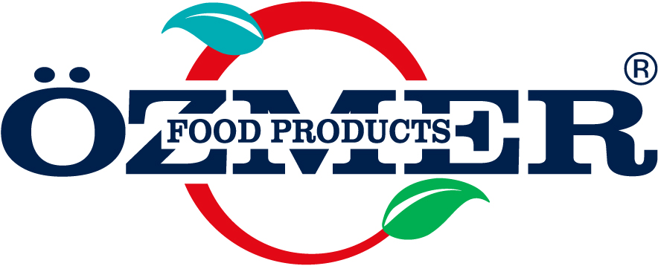 | FRUITED SAUCE  PRODUCT SPECIFICATION |  |  | Document No : SP-FP-208  1st Issue : 23.06.2015  Revision No : 01  Revision Date: 10.08.2021  Page No : 1 / 1
1. GENERAL CHARACTERISTICS:
Trade Mark : FO FOOD PRODUCTS
Product Name : LEMON FRUITED SAUCE
Packaging Amount/Type : 1 kg Polyethylene Bottle
Shipment : Shipped in closed cartoon packaging on lorries with closed containers.
Intended Area of Usage : Generally used in human nutrition, on ice cream, milky dessert, pastry, pies and cakes and between the waffle. Also,
maybe used in making fruited ice cream and frozen. As well as maybe used to give color and flavor to pastry and
cake dough, pies, cream, whipped cream, jellys and candy. As a sauce, gives a delicious taste to the applied product.
Type of Usage : Application is very practical. Frozen can be prepared as 1 volume sauce mixed with 3 volume crushed ice
in a high speed mixer.
For alcoholic and non alcoholic cocktails ; applied directly or consumed by diluting with water.
Storing Conditions : It should be stored in its original packaging, 20-22º C under dry conditions, and direct sunlight should be avoided.
Shelf life : The shelf life under defined storing conditions and in unopened packaging is 2 year.
2.PRODUCT INGREDIENTS :
INGREDIENTS | CLASS | EC CODE | MAXIMUM DOSAGE | PERCENTAGE
Sugar | — | — | — | 50 %
Lemon | — | — | — | 40%
Water | — | — | — | 5,396 %
Modified corn starch | Thickener | E 401 | QS | 2%
Citric Acid,Tripotassium citrate | Acidity Regulator | E 330, E332ii | — | 1%
Lemon flavored emission (Water, thickener (E414, E445), flavour, Acidity regülatör(E330), Antioksidant (E307),Preservative(E211), Clolr (E104,E110) |  | E414, E445  E330  E307  E211  E104,E110 |  | 1%
Flavoring (Lemon) | Flavoring | — | — | 0,5%
Potassium Sorbate | Preservative | E 202 | 1g/kg | 0,1 %
Quinoline Yellow | Colorant | E 104 | 50 mg/kg | 0,004 %
* The amount of Quinoline yellow ( E104 ) musn’t be higher than 50 mg/kg.
3.NUTRITIONAL INFORMATION: (Energy and Nutrition Facts 100 g)*;
Energy | 1030kj /246 kcal
Total Fat | 0,0 g
-of which saturates | 0,0 g
Cholesterol | 0,0 g
Total Carbohydrate | 58,0 g
Sugar | 54,9 g
Starch | 3,2 g
Dietary Fibre | 0,2 g
Protein | 0,1 g
Sodium/salt | 0,007 g/0,018 g
*( According to European Regulation (EU) No 1169/2011)
4. PHYSICAL CHARACTERISTICS:
Color/Taste/Odor: It has authentic lemon color, taste and odor.
Appearance : It is homogenous structure with lemon particles Does not have physically distinct. Does not include foreign materials.
5. CHEMICAL CHARACTERISTICS:
- pH : 2.2 ± 0.2
- Brix : 60 ± 2.0
6. CONTAMINANTS :
Cadmium (Cd) (mg/kg) | Max. 0,02
Arsenic (As) (mg/kg) | Max. 0,05
Mercury (Hg) (mg/kg) | Max. 0,01
Lead ( Pb) (mg/kg) | Max. 0,03
7. MICROBIOLOGICAL CHARACTERISTICS:
MICROORGANISM NAME | MICROBIOLOGICAL VALUE | ANALYSIS METHOD
Salmonella | 0/25 g-ml | EN/ISO 6579
L.Monocytogenes | 0/25 g-ml | EN/ISO 11290-1
E.Coli (cfu/g) | 0/25 g-ml | ISO 16649-2/3

8.ALLERGEN ALERT:
Does not contain any allergen.(According to European Regulation (EU) No 1169/2011)

9.GMO DECLARATION:
OZMER PASTACILIK A.S. declares under its responsibility that the product of this chart is produced with no GMO.
( According to European Regulation 2003/1829/CE,2003/1830/CE and subsequent modification.

10.REFERENCES:
OZMER PASTACILIK A.S. declares under its responsibility that the product of this chart is in accordance with the law in force;
* European Regulation 1333/2008/EC
* Commission Regulation (EU) 2023/915
* European Regulation 2073/2005/EC
* European Regulation 396/2005/EC and subsequent modifications.
PREPARED BY : |  | REVIEWED BY : | APPROVED BY :
R&D Manager |  | Quality Management Manager | General Manager
***Reviewed by the Quality DEPARTMENT on 11.06.2026***

